**System Requirements Specifications for Roadie**

Sponsor

**Electrical, Computer, Software & Systems Engineering at Embry-Riddle Aeronautical University**

Released 25 November 2014

**Are We There Yet?**

# **Revision History**

|  |  |  |
| --- | --- | --- |
| Date | Reason for Change | Version |
| 18 Nov 2014 | Initial Draft | 0.1.0 |

Table of Contents

**Revision History** ii

**1.** **Introduction** 1

**1.1** **Purpose** 1

**1.2** **Problem Statement** 1

**1.3** **Scope** 1

**1.4** **Team Information** 1

**1.5** **Overview** 1

**2.** **System State Definitions** 2

**2.1** **Coordination System State Diagram** 3

**3.** **Functional Decomposition of System** 3

**3.1** **High-Level Architecture of System** 4

**4.** **Decomposition of Coordination System** 5

**4.1** **Requirements** 6

**4.1.1** **Navigation** 6

**4.2** **Use Cases** 6

**4.2.1** **Use Case 1: Line Following** 7

**4.2.2** **Arrival at Challenge Zone** 9

**4.3** **Sequence Diagrams** 10

**4.4** **Traceability Matrix** 10

**5.** **Decomposition of Challenge System** 11

**5.1** Requirements 11

**5.2** Use Cases 11

**5.3** Traceability Matrix 11

**6.** **Decomposition of Movement System** 12

**6.1** Requirements 12

**6.2** Use Cases 12

**6.3** Traceability Matrix 12

**7.** **Appendix A** 13

**8.** **Glossary** 17

**9.** **Appendix B** 19

**9.1** **Competition Course** 19

**9.2** **Simon Carabiner** 20

**9.3** **Rubik’s Cube** 21

**9.4** **Pocket Etch-A-Sketch** 22

**9.5** **Playing Cards** 23

**9.6** **Scotch Blue Painter’s Tape** 24

**10.** **References** 25

Table of Figures

**Fig. 1**: State diagram for the Coordination System 3

**Fig. 2**: Division of Roadie into three subsystems. 4

**Fig. 3**: High level description of the systems in Roadie. 5

**Fig. 4**: Decomposition of coordination system for Roadie. 5

**Fig. 5**: Decomposition of Challenge System for Roadie. 11

**Fig. 6**: Decomposition of Movement System Roadie. 12

**Fig. 7** Competition course for SoutheastCon[1]. 19

**Fig. 8:** The exact Simon Carabiner to be used during competition [5]. 20

**Fig. 9:** The exact Rubik's Cube to be used during competition [6]. 21

**Fig. 10:** The exact pocket Etch-A-Sketch to be used during competition [7]. 22

**Fig. 11:** The exact playing cards to be used during competition [9]. 23

**Fig. 12:** The exact painter’s tape to be used on the course [8]. 24

# **Introduction**

## **Purpose**

The purpose of this document is to define the system requirements of Roadie, the robot put forth by team Are We There Yet (AWTY) to compete in the 2015 Institute of Electrical and Electronics Engineers (IEEE) SoutheastCon student hardware competition. These requirements include both functional requirements and non-functional requirements. This document is intended for the customer of AWTY, the requirements engineering team for AWTY, the design, testing and quality assurance teams, as well as all other teams involved in the development and construction.

## **Problem Statement**

To create an autonomous robot to compete in the 2015 IEEE SoutheastCon student hardware competition.

## **Scope**

Roadie is intended to compete in the 2015 IEEE Southeast Con student hardware competition. The system is envisioned to complete four unique challenges:

* Correctly play Simon for 15 seconds
* Draw “IEEE” on an Etch-A-Sketch
* Twist one row of a Rubik’s cube 180 degrees
* Pick up and carry one playing card across the finish line

Roadie system is intended to successfully complete the challenges outlined above within a time limit of five minutes.

Roadie is not intended to serve any other functions or fulfill any other purposes other than competing in the 2015 IEEE SoutheastCon competition.

## **Team Information**

|  |  |
| --- | --- |
| Name | Role |
| Brian Powell | Team Leader |
| Michael Philotoff |  |
| Alex Senopoulos |  |
| Brian Sterling |  |

## **Overview**

# **System State Definitions**

In order to better define transitions and states that the system will occupy, Table 1 has been constructed, providing both the state name, and the description of the associated state.

|  |  |
| --- | --- |
| State Name | State Description |
| Approach | The state in which the system will be once it has entered a challenge area. The approach stage will consist of the system placing itself 4.2 cm ± 0.1 cm from the challenge. |
| Challenge Abortion | The state in which the system will enter upon incorrectly interacting with a challenge. When the system enters this state, it will immediately halt execution of the current challenge, exiting the challenge area and proceeding to the line following state. |
| Challenge Completion | The state in which the system will enter upon successfully completing a challenge. This system will remain in this state until exiting the challenge area. |
| Challenge Identification | The state in which the system attempts to identify the challenge it has arrived at. The system remains in this state until a positive identification. |
| Challenge Interaction | The state in which the system will attempt to complete a challenge. The system will remain in this state for as long as it is interacting with a challenge. |
| Challenge Misidentification | The state in which the system will enter upon falsely identifying the challenge it has arrived at. Should the system enter this state, this will represent a catastrophic failure. The system will proceed to the challenge abortion state. |
| Failed Approach | The state in which the system will enter upon stopping close than or further than 4.2 cm ± 0.1 cm. The system will proceed back to the approach state. |
| Finish | The state in which the system will enter upon crossing the finish line. The system will cease all movement. |
| Line Abandonment | The state in which the system will enter upon failing to proceed along the guidance tape. Should the system enter this state, the system will reverse direction to the last known location of the guidance tape. |
| Line Following | The state in which Roadie is following the Scotch Blue Painter’s tape located on the competition area. |
| Staging | The state in which the system commences operation. This state will last from the time the system is placed inside the starting area, until the LED in the starting area is turned off. |
| Zone Identification | The state in which the system will enter upon recognizing a challenge zone or finishing line. |
| Etch-A-Sketch | The state in which the system will attempt to complete the Etch-A-Sketch challenge. |
| Rubik’s Cube | The state in which the system will attempt to complete the Rubik’s Cube challenge. |
| Simon | The state in which the system will attempt to complete the Simon challenge. |
| Playing Card | The state in which the system will attempt to complete the playing card challenge. |
| Zone Misidentification | The state in which the system will enter upon failing to recognize a challenge zone. If the system were to enter this state, that would represent a catastrophic failure, resulting in termination of the round. |

Table 1: States that the system will occupy with their accompanying description.

By using Table 1, it was possible to construct the state diagrams shown in the sections below.

## **Coordination System State Diagram**

**Fig. 1** below shows the states that the Coordination System will be in, and how the system will transition from state to state.

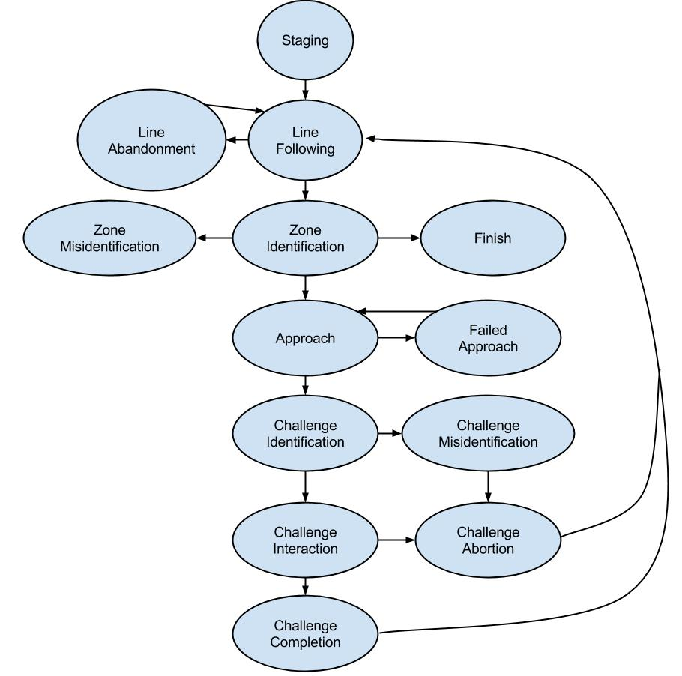

**Fig. 1**: State diagram for the Coordination System

# **Functional Decomposition of System**

Roadie is broken down three main subsystems: (1) the coordination subsystem, (2) the challenge subsystem and (3) the motion subsystem. The division of these subsystems is illustrated in **Fig. 1**.

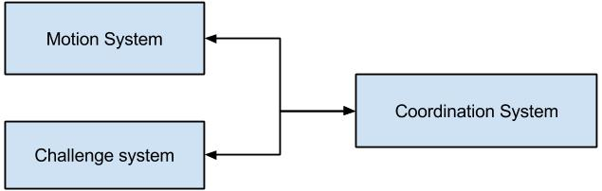

**Fig. 2**: Division of Roadie into three subsystems.

The communication and coordination subsystem relays information to both the arm subsystem and the movement subsystem. The components of Roadie were broken into subsystems based upon what other components they interacted with and what task they set out to perform. For example, all of the interactors for challenges (Simon, Etch-A-Sketch, Rubik’s cube and playing card), were divided into the Challenge System since the interactors represent the means through which Roadie will physically manipulate the challenges. The Coordination System encompasses the microcontrollers as well as the camera and line sensors. The reasoning behind such a decisions is that the camera and line sensors will send correction information that will be interpreted by the microcontroller to navigate the Roadie to the right challenge as well as identify the correct challenge upon arrival. The motion system is comprised of the motors and their associated wheels. This is due to the fact that the motors and wheels are responsible for moving the system to the intended destination.

These subsystems are further divided by functionality to create the high-level architecture as described in Sections 2.1, 2.2 and 2.3.

## **High-Level Architecture of System**

The system architecture of Roadie is designed in a layered approach, depicted in **Fig*.* 2** below, in order to better divide the work being done and to aid in the conceptualization of the system design.

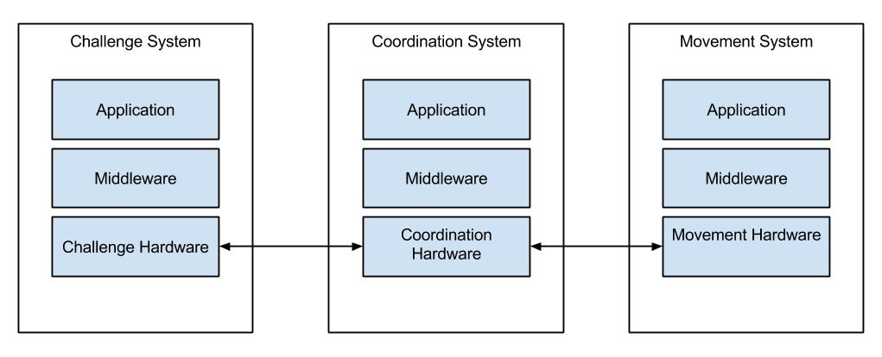

**Fig. 3**: High level description of the systems in Roadie.

The applications in the Coordination System represent feedback from the sensors (reflectance and camera) which is translated by the middleware (software) to the physical communications means. From here, the Challenge System and the Motion System are directed by the Coordination System in order to navigate to challenges (Motion System) and complete the challenges (Challenge System). From there, middleware in the form of software is used to talk to the applications. In this instance, the application in the Challenge System represents the challenges (Simon Carabiner, pocket Etch-A-Sketch, Rubik’s cube, picking up a playing card), with the motion application being moving the whole system along the competition area. As Roadie progresses along, the Communication System constantly sends correction information to the Motion System as well as monitor the Motion System’s behavior to correct any anomalies.

# **Decomposition of Coordination System**

**Fig. 3** below, better illustrates the communications that occur amongst the systems in Roadie.

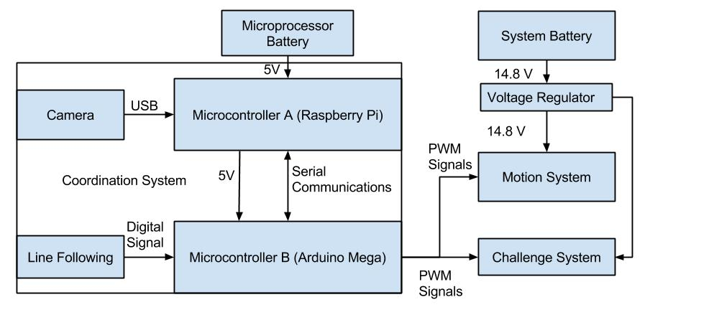

**Fig. 4**: Decomposition of coordination system for Roadie.

As depicted in **Fig. 3**, the Coordination System is composed of two microcontrollers, both communicating with each other over a serial interface. The Arduino Mega is the primary micro controller, interpreting inputs from the reflectance array (line following) and issuing commands based on values received.

All of the communications originating from the Coordination System are a hard wire connection. That is to say that all of the communications occur over a physical medium. The Arduino issues commands to the Motion System and the Challenge System via pulse width modulation (PWM) signals through wires connected to the Arduino’s PWM ports. Similarly, communications within the Coordination System occur over a physical medium. The Raspberry Pi and the Arduino communicate via a serial communications over a USB cable. The camera is activated by the Raspberry Pi via serial signals over a USB cable as well. The line following array communicates via digital high and low signals over wires connected to the digital pins on the Arduino.

## **Requirements**

This section details the requirements placed on the coordination system. They include requirements on the navigation, ability to identify challenges and hardware requirements for the system.

### **Navigation**

COR 1. The system shall commence operation from the starting area.

COR 2. The system shall progress forward along the blue guidance tape until reaching a challenge zone or reaching the finish line.

COR 3 The system shall **some metric about line following**

COR 4 The system shall identify the challenge zone upon arrival.

COR 4.1 The system shall enter the approach state.

COR 4.2 The system shall enter the challenge identification state upon exiting the approach state

COR 4.3 Upon completing the challenge, the system shall exit the challenge zone, continuing back to the line following state.

COR 5 The system shall wait for the red LED in the starting area to turn off before exiting the starting area.

### **Challenge Identification**

COR 6 The system shall correctly identify the challenge within 10 seconds of arrival in a challenge zone

COR 6.1 The system shall correctly identify the challenge within 5 seconds of entering the challenge identifications state.

COR 6.2 The system shall correctly identify the Simon Carabiner depicted in **Fig. 8**.

COR 6.3 The system shall correctly identify the Rubik’s Cube depicted in **Fig. 9**

COR 6.4 The system shall correctly identify the pocket Etch-A-Sketch depicted in **Fig. 10**

COR 6.5 The system shall correctly identify the playing cards depicted in **Fig. 11**

COR 7 The system shall determine the center of the challenge relative to the center of the leading edge of the chassis.

COR 7.1 The system shall align with the challenge if the challenge is not within 0.1 cm of the center of the leading edge of the chassis

### **Hardware**

COR 8 The system shall possess at least two USB ports

COR 9 The system shall possess the ability to communicate with a remote PC wirelessly

COR 10 The system shall possess the ability to run computer vision software.

COR 11 The system shall possess the ability to generate pulse width modulation signals.

COR 12 The system shall be completely autonomous after being powered on.

COR 13 The system shall operate for a minimum of 30 minutes when the power source starts with a full charge.

## **Use Cases**

The following use cases demonstrate the intended operations of the Coordination System of Roadie. The use cases outline the intended sequence of events as well as the procedures that will be followed in the event of a system failure.

Note: “*” indicates at any given time, during the use case.

### **4.2.1** Use Case 1: Line Following

Scope: Roadie

Level: User goal

Primary Actors: Roadie

**Stakeholders & Interests**

* **Team AWTY** - as the development team for Roadie, Roadie’s performance in the challenge will reflect directly back upon them.
* **Dr. Barott, Dr. Seker and Mr. Jorge Torres –** as customers of Team AWTY, there is an expectation that Roadie will compete successfully in the challenge.
* **ERAU –** the system represents the quality of the education at the University as well as the technical ability of the sponsors and the department.
* **ECSSE Department –** direct sponsor of Team AWTY expects Roadie to compete in and complete the challenge to the best of its abilities.
* **IEEE –** competition sponsor expects Team AWTY to conduct themselves in a manner befitting of a professional organization as well as to demonstrate innovate solutions to technical challenges.

**Preconditions**

* Roadie has been placed in the 1 ft. x 1 ft. starting area on the competition area.
* Roadie has been turned to the on position.

**Postconditions**

* Roadie crosses the finish line.

**Main Success Scenario**

1. Roadie waits for the red LED to turn off before entering into the Line Following State.
2. Roadie enters into the Line Following State and starts line following making turns based on which way the line is turning until reaching the first challenge.
3. After completing the first challenge, Roadie turns around and begins to line follow until reaching the second challenge.
4. After completing the second challenge, Roadie turns around and beings to line follow until reaching the third challenge.
5. After completing the third challenge, Roadie turns around and beings to line follow until reaching the fourth challenge.
6. After completing the fourth challenge, Roadie turns around and beings to line follow until crossing the finish line.

**Extensions (Alternate Flows)**

*a. Roadie is no longer following the guidance tape.

*b. Roadie has failed to identify a challenge zone.

**Frequency of Occurrence**

This use case will occur each time the system is placed within the 1 ft. x 1 ft. white square. During the competition this shall occur three times due to there being three rounds for each robot that is entered.

### **4.2.2** **Use Case 2: Arrival at Challenge Zone**

Scope: Roadie

Level: User goal

Primary Actors: Roadie

**Stakeholders & Interests**

* **Team AWTY** - as the development team for Roadie, Roadie’s performance in the challenge will reflect directly back upon them.
* **Dr. Barott, Dr. Seker and Mr. Jorge Torres –** as customers of Team AWTY, there is an expectation that Roadie will compete successfully in the challenge.
* **ERAU –** the system represents the quality of the education at the University as well as the technical ability of the sponsors and the department.
* **ECSSE Department –** direct sponsor of Team AWTY expects Roadie to compete in and complete the challenge to the best of its abilities.
* **IEEE –** competition sponsor expects Team AWTY to conduct themselves in a manner befitting of a professional organization as well as to demonstrate innovate solutions to technical challenges.

**Preconditions**

* Roadie has reached a challenge zone.

**Postconditions**

* Roadie has correctly identified what challenge zone it has arrived at.

**Main Success Scenario**

1. Roadie correctly detects it has arrived at a challenge zone.
2. Roadie begins to approaches the object.
3. Roadie halts movement at 4.2 cm ± 0.1 cm from the challenge.
4. Roadie correctly initiates the challenge detection process.
5. Roadie correctly identifies the challenge it has arrived at within 5 seconds of initiating the challenge detection process.
6. Roadie determines the alignment of the challenge relative to the leading edge of the chassis.
7. Roadie correctly determines the direction and distance to move laterally (left or right) to align with the challenge.
8. Roadie repeats steps 6 and 7 until it is aligned within 0.1 cm of the leading edge of the chassis.
9. Roadie enters a challenge interaction state.

**Extensions (Alternate Flows)**

*a. Roadie fails to correctly detects it has arrived at a challenge zone.

1. Roadie will enter the zone misidentification state.

*b. Roadie fails to halt movement at 4.2 cm ± 0.1 cm from the challenge.

1. Roadie will proceed to the failed approach state

*d. Roadie fails to correctly detect the challenge.

1. Roadie will proceed to the challenge misidentification state

*e. Roadie fails to correctly identify the challenge within 5 seconds of initiating the challenge identification state.

1. Roadie will continue to attempt to identify the object for another 25 seconds. If Roadie is still unsuccessful, Roadie will proceed to the challenge misidentification state.

**Frequency of Occurrence**

This use case will occur every time Roadie reaches a challenge zone. During the competition this shall occur four times due to there being four challenge zones on the competition area.

## **Sequence Diagrams**

## **Traceability Matrix**

|  |  |  |  |
| --- | --- | --- | --- |
| Previous Requirement Number | Previous Requirement Text | New Requirement Number | Fulfillment Justification |
| 3.2.1 | The system shall start in the starting area | COR 1 | The new requirement is able to fulfill the previous L1 requirement as it is simply an extension of the previous L1 requirement. The new requirement has been refined so that the operation being performed in the starting area is less vague. |
| 3.2.2 | The system shall progress forward along the blue guidance tape until reaching a challenge area or reaching the finish line. | COR 2 | This requirement has not been changed from the previous version. |
| 3.2.3 | The system shall identify the challenge zone and stop movement upon arrival. | COR 4 , COR 4.1, COR 4.2, COR 4.3 | The previous requirement implied that the system would halt all movement once entering a challenge zone. Since there are four challenge zones in the competition area, this requirement needed to be refined. As such, the original requirement has been split into three different requirements, each detailing what is required of the system upon arriving in a challenge area. |
| 3.3.1 | The system shall correctly identify the challenge upon arrival. | COR 5 | The previous requirement has had a time value added to it to impose a performance characteristic on the system. This will aid in completing the course within the allotted time. |
| 3.3.1.1 | The system shall correctly identify the Simon Carabiner depicted in **Fig. 8**. | COR 5.2 | This requirement has not been changed from the previous version. |
| 3.3.1.2 | The system shall correctly identify the Rubik’s Cube depicted in **Fig. 9.** | COR 5.3 | This requirement has not been changed from the previous version. |
| 3.3.1.3 | The system shall correctly identify the pocket Etch-A-Sketch depicted in **Fig. 10**. | COR 5.4 | This requirement has not been changed from the previous version. |
| 3.3.1.4 | The system shall correctly identify the playing cards depicted in **Fig.** [TBD]. | COR 5.5 | With the specification of the card type, this requirement has been refined to include the specific card being used. |
| 3.3.2 | The system shall align with the challenge before attempting to complete the challenge. | COR 6, COR 6.1 | The previous requirement did not account for the possibility that the system may already be aligned with the challenge. As such, it has been broken into two separate requirements, one dealing with the instance in which the system is already aligned, the other dealing with the case in which the system is not aligned. |
| 4.3.2 | The system shall be completely autonomous after being powered on. | COR 11 | This requirement has not been changed from the previous version. |

# **Decomposition of Challenge System**

**Fig. 4** shows the decomposition of the Challenge System into its major components.

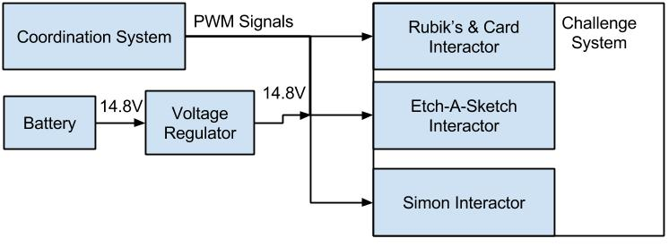

**Fig. 5**: Decomposition of Challenge System for Roadie.

Signals into this subsystem originate from the Coordination System via PWM signals from the Arduino’s PWM ports. The signals designate what interactor is to activate and what challenge sequence is to be completed. Power for each interactor is sourced from a 14.8V battery.

## Requirements

This section details the requirements placed on the challenge system. Requirements in this section include how the system will interact with each individual challenge, and what the expected behavior is during interaction.

### Simon Interactor

CHA 1 The system shall play the Simon Carabiner.

CHA 2 The system shall play the Simon Carabiner for 15 seconds.

CHA 3 The system shall initiate the Simon Carabiner by pressing the start button.

CHA 4 The system shall correctly sense when the blue segment is illuminated on the Simon Carabiner.

CHA 5 The system shall correctly sense when the red segment is illuminated on the Simon Carabiner.

CHA 6 The system shall correctly sense when the yellow segment is illuminated on the Simon Carabiner.

CHA 7 The system shall correctly sense when the green segment is illuminated on the Simon Carabiner.

CHA 8 The system shall not obstruct the Simon Carabiner during play

CHA 9 The system shall respond to the last color in the Simon sequence within 5 seconds.

### Rubik’s Interactor

CHA 10 The system shall twist one row of a Rubik’s Cube 180 degrees within 10 seconds of entering the Rubik’s Cube state.

CHA 11 The system shall not obstruct the Rubik’s Cube during play.

### Etch-A-Sketch and Card Interactor

CHA 12 The system shall draw “IEEE” on the pocket Etch-A-Sketch within 1 minute of entering the Etch-A-Sketch state.

CHA 13 The system shall use block letters for drawing “IEEE”.

CHA 14 The system shall not obstruct the pocket Etch-A-Sketch during play.

CHA 15 The system shall collect a single Bicycle brand standard playing card as shown in **Fig. 11**

CHA 16 The system shall carry playing card across finish line.

CHA 17 The system shall keep the card in a usable condition.

## Use Cases

The following use cases demonstrate the intended operations of the Challenge System of Roadie. The use cases outline the intended sequence of events as well as the procedures that will be followed in the event of a system failure.

Note: “*” indicates at any given time, during the use case.

### Use Case 3: Simon Carabiner Challenge

Scope: Roadie

Level: User goal

Primary Actors: Roadie

**Stakeholders & Interests**

* **Team AWTY**  - as the development team for Roadie, Roadie’s performance in the challenge will reflect directly back upon them.
* **Dr. Barott, Dr. Seker and Mr. Jorge Torres –** as customers of Team AWTY, there is an expectation that Roadie will compete successfully in the challenge.
* **ERAU –** the system represents the quality of the education at the University as well as the technical ability of the sponsors and the department.
* **ECSSE Department –** direct sponsor of Team AWTY expects Roadie to compete in and complete the challenge to the best of its abilities.
* **IEEE –** competition sponsor expects Team AWTY to conduct themselves in a manner befitting of a professional organization as well as to demonstrate innovate solutions to technical challenges.

**Preconditions**

* Roadie has reached the Simon Carabiner challenge zone.

**Postconditions**

* Roadie completes playing Simon Carabiner for 15 seconds.

**Main Success Scenario**

1. Roadie aligns itself up with the Simon Carabiner as described in Use Case: Arrival at Challenge Zone.
2. Roadie pushes the start button located on the Simon Carabiner.
3. Roadie correctly identifies which colors and order the Simon Carabiner has lit up.
4. Roadie pushes each button in the order at which the Simon Carabiner has lit up.
5. Roadie repeats steps 4 and 5 until 15 seconds has passed.

**Extensions (Alternate Flows)**

*a. Roadie fails to respond or correctly push buttons in order to where Simon signals the failure sound.

1. Roadie shall proceed to the next challenge zone or finish line.

**Frequency of Occurrence**

This use case will occur every time Roadie reaches and identifies the challenge to be the Simon Carabiner challenge. During the competition this shall occur three times due to there being three rounds for each robot that is entered and this challenge shall occur once per round.

### Use Case 4: Pocket Etch-A-Sketch Challenge

Scope: Roadie

Level: User goal

Primary Actors: Roadie

**Stakeholders & Interests**

* **Team AWTY**  - as the development team for Roadie, Roadie’s performance in the challenge will reflect directly back upon them.
* **Dr. Barott, Dr. Seker and Mr. Jorge Torres –** as customers of Team AWTY, there is an expectation that Roadie will compete successfully in the challenge.
* **ERAU –** the system represents the quality of the education at the University as well as the technical ability of the sponsors and the department.
* **ECSSE Department –** direct sponsor of Team AWTY expects Roadie to compete in and complete the challenge to the best of its abilities.
* **IEEE –** competition sponsor expects Team AWTY to conduct themselves in a manner befitting of a professional organization as well as to demonstrate innovate solutions to technical challenges.

**Preconditions**

* Roadie has arrived at the pocket Etch-A-Sketch challenge zone.

**Postconditions**

* Roadie completes drawing “IEEE” using the pocket Etch-A-Sketch.

**Main Success Scenario**

1. Roadie aligns itself up with the Etch-A-Sketch as described in Use Case: Arrival at Challenge Zone.
2. Roadie twists the two knobs to draw “IEEE” in block letters on the pocket Etch-A-Sketch.

**Extensions (Alternate Flows)**

*a. Roadie is in a bad state.

1. Roadie will backtrack last known good state.

2. Roadie shall proceed with the next steps to take.

**Frequency of Occurrence**

This use case will occur every time Roadie reaches and identifies the challenge to be the pocket Etch-A-Sketch challenge. During the competition this shall occur three times due to there being three rounds for each robot that is entered and this challenge shall occur once per round.

### Use Case 5: Rubik’s Cube Challenge

Scope: Roadie

Level: User goal

Primary Actors: Roadie

**Stakeholders & Interests**

* **Team AWTY**  - as the development team for Roadie, Roadie’s performance in the challenge will reflect directly back upon them.
* **Dr. Barott, Dr. Seker and Mr. Jorge Torres –** as customers of Team AWTY, there is an expectation that Roadie will compete successfully in the challenge.
* **ERAU –** the system represents the quality of the education at the University as well as the technical ability of the sponsors and the department.
* **ECSSE Department –** direct sponsor of Team AWTY expects Roadie to compete in and complete the challenge to the best of its abilities.
* **IEEE –** competition sponsor expects Team AWTY to conduct themselves in a manner befitting of a professional organization as well as to demonstrate innovate solutions to technical challenges.

**Preconditions**

* Roadie has arrived at the Rubik’s Cube challenge zone.

**Postconditions**

* Roadie twisted a row of the Rubik’s Cube 180 degrees.

**Main Success Scenario**

1. Roadie aligns itself up with the Rubik’s Cube as described in Use Case: Arrival at Challenge Zone.
2. Roadie twist one of the rows of Rubik’s Cube 180 degrees.

**Extensions (Alternate Flows)**

*a. Roadie is in a bad state.

1. Roadie will backtrack last known good state.

2. Roadie shall proceed with the next steps to take.

**Frequency of Occurrence**

This use case will occur every time Roadie reaches and identifies the challenge to be the Rubik’s Cube challenge. During the competition this shall occur three times due to there being three rounds for each robot that is entered and this challenge shall occur once per round.

### Use Case 6: Playing Card Challenge

Scope: Roadie

Level: User goal

Primary Actors: Roadie

**Stakeholders & Interests**

* **Team AWTY**  - as the development team for Roadie, Roadie’s performance in the challenge will reflect directly back upon them.
* **Dr. Barott, Dr. Seker and Mr. Jorge Torres –** as customers of Team AWTY, there is an expectation that Roadie will compete successfully in the challenge.
* **ERAU –** the system represents the quality of the education at the University as well as the technical ability of the sponsors and the department.
* **ECSSE Department –** direct sponsor of Team AWTY expects Roadie to compete in and complete the challenge to the best of its abilities.
* **IEEE –** competition sponsor expects Team AWTY to conduct themselves in a manner befitting of a professional organization as well as to demonstrate innovate solutions to technical challenges.

**Preconditions**

* Roadie has arrived at the card challenge zone.

**Postconditions**

* Roadie has picked up a single playing card.

**Main Success Scenario**

1. Roadie aligns itself up with the playing card as described in Use Case: Arrival at Challenge Zone.
2. Roadie picks up a single playing card.
3. Roadie continues to carry the playing card that was picked up.

**Extensions (Alternate Flows)**

*a. Roadie is in a bad state.

1. Roadie will backtrack last known good state.

2. Roadie shall proceed with the next steps to take.

**Frequency of Occurrence**

This use case will occur every time Roadie reaches and identifies the challenge to be the playing card challenge. During the competition this shall occur three times due to there being three rounds for each robot that is entered and this challenge shall occur once per round.

## Sequence Diagrams

## Traceability Matrix

# **Decomposition of Movement System**

**Fig. 5** shows the decomposition of Roadie’s movement System into major components.

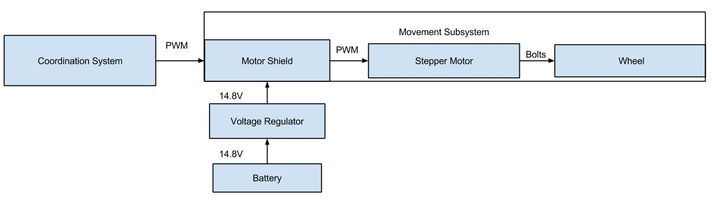

**Fig. 6**: Decomposition of Movement System Roadie.

Signals into this subsystem originate from the Coordination System via PWM signals from the Arduino’s PWM ports. The signals are sent to a motor shield, which interprets the signals and activates the correct motor. When the motor receives a signal to activate, it turns a wheel which is connected via bolts. Power to the Movement System is sourced from a 14.8V battery.

## Requirements

This section details the requirements placed on the movement system. Requirements in this section include how the chassis shall behave as well as how the system shall move.

### Chassis Requirements

MOV 1 The system size shall be no greater than 1ft. x 1ft. x 1ft. within the starting area and the finishing area.

MOV 2 The system shall operate for a minimum of 30 minutes when the power source starts with a full charge.

MOV 3 The system shall have an easily accessible power switch.

MOV 4 The system shall maintain contact with the competition area’s surface at all times.

### Movement Requirements

MOV 5 The system shall move in the competition area shown in **Fig. 7**.

MOV 6 The system shall move from the starting area to the first challenge location along the Scotch Blue Painter’s tape (guidance tape).

MOV 7 The system shall move from the first challenge location to the second challenge location along the guidance tape.

MOV 8 The system shall move from the second challenge location to the third challenge location along the guidance tape.

MOV 9 The system shall move from third challenge location to the fourth challenge location along the guidance tape.

MOV 10 The system shall move from the fourth challenge location to the finish line along the guidance tape.

MOV 11 The system shall move at a pace sufficient to fully complete the course within five minutes.

## Use Cases

### Use Case 7: Line Following

Scope: Roadie

Level: User goal

Primary Actors: Roadie

**Stakeholders & Interests**

* **Team AWTY**  - as the development team for Roadie, Roadie’s performance in the challenge will reflect directly back upon them.
* **Dr. Barott, Dr. Seker and Mr. Jorge Torres –** as customers of Team AWTY, there is an expectation that Roadie will compete successfully in the challenge.
* **ERAU –** the system represents the quality of the education at the University as well as the technical ability of the sponsors and the department.
* **ECSSE Department –** direct sponsor of Team AWTY expects Roadie to compete in and complete the challenge to the best of its abilities.
* **IEEE –** competition sponsor expects Team AWTY to conduct themselves in a manner befitting of a professional organization as well as to demonstrate innovate solutions to technical challenges.

**Preconditions**

* Roadie has left the starting area or has just finished a challenge and has entered the line following state.

**Postconditions**

* Roadie arrives at the next challenge area, right or left turn, an intersection, or reaches the finish line after completing all of the challenges.

**Main Success Scenario**

1. Roadie moves forward on the line.
2. Roadie continues makes adjustments to stay on the line.
3. Repeat steps one and two until reaching a challenge area, finish line, right or left turn, or an intersection.

**Extensions (Alternate Flows)**

*a. Roadie is in a bad state.

1. Roadie will backtrack last known good state.

2. Roadie shall proceed with the next steps to take.

**Frequency of Occurrence**

This use case will occur every time Roadie is in the line following state during the navigation between the starting area and the next challenge area or finish line. During the competition this shall occur three times due to there being three rounds for each robot that is entered.

### Use Case 8: Right Turn

Scope: Roadie

Level: User goal

Primary Actors: Roadie

**Stakeholders & Interests**

* **Team AWTY**  - as the development team for Roadie, Roadie’s performance in the challenge will reflect directly back upon them.
* **Dr. Barott, Dr. Seker and Mr. Jorge Torres –** as customers of Team AWTY, there is an expectation that Roadie will compete successfully in the challenge.
* **ERAU –** the system represents the quality of the education at the University as well as the technical ability of the sponsors and the department.
* **ECSSE Department –** direct sponsor of Team AWTY expects Roadie to compete in and complete the challenge to the best of its abilities.
* **IEEE –** competition sponsor expects Team AWTY to conduct themselves in a manner befitting of a professional organization as well as to demonstrate innovate solutions to technical challenges.

**Preconditions**

* Roadie reaches a right turn and exits the line following state.

**Postconditions**

* Roadie makes a 90 degree turn to the right and enters the line following state.

**Main Success Scenario**

1. Roadie arrives at a right turn.
2. Roadie continues to move forward until the center of Roadie is at the right turn.
3. Roadie checks to see if the line continues forwards and turns right then set a flag if the line continues forward.
4. Roadie turn to the right 90 degrees.
5. Roadie enters the line following state and begins moving forward again.

**Extensions (Alternate Flows)**

*a. Roadie is in a bad state.

1. Roadie will backtrack last known good state.

2. Roadie shall proceed with the next steps to take.

**Frequency of Occurrence**

This use case will occur every time Roadie reaches a right turn during the navigation between the starting area and the next challenge area or finish line. During the competition this shall occur three times due to there being three rounds for each robot that is entered.

### Use Case 9: Left Turn

Scope: Roadie

Level: User goal

Primary Actors: Roadie

**Stakeholders & Interests**

* **Team AWTY**  - as the development team for Roadie, Roadie’s performance in the challenge will reflect directly back upon them.
* **Dr. Barott, Dr. Seker and Mr. Jorge Torres –** as customers of Team AWTY, there is an expectation that Roadie will compete successfully in the challenge.
* **ERAU –** the system represents the quality of the education at the University as well as the technical ability of the sponsors and the department.
* **ECSSE Department –** direct sponsor of Team AWTY expects Roadie to compete in and complete the challenge to the best of its abilities.
* **IEEE –** competition sponsor expects Team AWTY to conduct themselves in a manner befitting of a professional organization as well as to demonstrate innovate solutions to technical challenges.

**Preconditions**

* Roadie reaches a left turn and exits the line following state.

**Postconditions**

* Roadie makes a 90 degree turn to the left and enters to the line following state.

**Main Success Scenario**

1. Roadie arrives at a left turn.
2. Roadie continues to move forward until the center of Roadie is at the left turn.
3. Roadie checks to see if the line continues forwards and turns right left set a flag if the line continues forward.
4. Roadie turn to the left 90 degrees.
5. Roadie enters the line following state and begins moving forward again.

**Extensions (Alternate Flows)**

*a. Roadie is in a bad state.

1. Roadie will backtrack last known good state.

2. Roadie shall proceed with the next steps to take.

**Frequency of Occurrence**

This use case will occur every time Roadie reaches a left turn during the navigation between the starting area and the next challenge area or finish line. During the competition this shall occur three times due to there being three rounds for each robot that is entered.

### Use Case 10: Intersection

Scope: Roadie

Level: User goal

Primary Actors: Roadie

**Stakeholders & Interests**

* **Team AWTY**  - as the development team for Roadie, Roadie’s performance in the challenge will reflect directly back upon them.
* **Dr. Barott, Dr. Seker and Mr. Jorge Torres –** as customers of Team AWTY, there is an expectation that Roadie will compete successfully in the challenge.
* **ERAU –** the system represents the quality of the education at the University as well as the technical ability of the sponsors and the department.
* **ECSSE Department –** direct sponsor of Team AWTY expects Roadie to compete in and complete the challenge to the best of its abilities.
* **IEEE –** competition sponsor expects Team AWTY to conduct themselves in a manner befitting of a professional organization as well as to demonstrate innovate solutions to technical challenges.

**Preconditions**

* Roadie reaches an intersection and exits the line following state.

**Postconditions**

* Roadie makes a left or right turn depending on the intersection and sets a flag for which way Roadie turned and enters the line following state.

**Main Success Scenario**

1. Roadie arrives at an intersection.
2. Roadie checks the intersection flag to decide which way to turn left or right.
3. Roadie moves forward until Roadie in centered above the intersection.
4. Roadie makes a turn based on the intersection flag.
5. Roadie enters the line following state.

**Extensions (Alternate Flows)**

*a. Roadie is in a bad state.

1. Roadie will backtrack last known good state.

2. Roadie shall proceed with the next steps to take.

**Frequency of Occurrence**

This use case will occur every time Roadie reaches an intersection during the navigation between the starting area and the next challenge area or finish line. During the competition this shall occur three times due to there being three rounds for each robot that is entered.

### Use Case 11: Full Movement

Scope: Roadie

Level: User goal

Primary Actors: Roadie

**Stakeholders & Interests**

* **Team AWTY**  - as the development team for Roadie, Roadie’s performance in the challenge will reflect directly back upon them.
* **Dr. Barott, Dr. Seker and Mr. Jorge Torres –** as customers of Team AWTY, there is an expectation that Roadie will compete successfully in the challenge.
* **ERAU –** the system represents the quality of the education at the University as well as the technical ability of the sponsors and the department.
* **ECSSE Department –** direct sponsor of Team AWTY expects Roadie to compete in and complete the challenge to the best of its abilities.
* **IEEE –** competition sponsor expects Team AWTY to conduct themselves in a manner befitting of a professional organization as well as to demonstrate innovate solutions to technical challenges.

**Preconditions**

* Roadie exits the starting area.

**Postconditions**

* Roadie reaches the finish line.

**Main Success Scenario**

1. Roadie enters the line following state.
2. Roadie follows the line as described in use case: Line following.
3. Roadie reaches a turn, intersection, or challenge zone.
4. Roadie decided what to do based on which zone has been reached according to the use case: Right Turn, Left Turn, or Intersection.
5. Repeat steps one through 4 until reach the finish line.

**Extensions (Alternate Flows)**

*a. Roadie is in a bad state.

1. Roadie will backtrack last known good state.

2. Roadie shall proceed with the next steps to take.

**Frequency of Occurrence**

This use case will occur every time Roadie exits the starting area or challenge area until reach the finish line. During the competition this shall occur three times due to there being three rounds for each robot that is entered.

## Traceability Matrix

# **Appendix A**

Appendix A includes all of the requirements presented in the System Requirements Specifications for Roadie, version 1.0.0, dated 2014-09-18. The requirement text is shown, followed by changes, signified by a red strike-through. The resulting revised requirement in shown in the final column. This information is displayed in **Table** 1below:

|  |  |  |  |  |
| --- | --- | --- | --- | --- |
| Previous Requirement Number | Previous Text | Changes | Resulting Requirement Text | New Requirement Number |
| 3.1.1 | The system shall move in the competition area shown in **Fig. 7**. | N/A | The system shall move in the competition area shown in **Fig. 7**. | MOV 5 |
| 3.1.2 | The system shall move from the starting area to the Simon Carabiner along the Scotch Blue Painter’s tape (guidance tape). | The system shall move from the starting area to the ~~Simon Carabiner~~ first challenge location along the Scotch Blue Painter’s tape (guidance tape). | The system shall move from the starting area to the first challenge location along the Scotch Blue Painter’s tape (guidance tape). | MOV 6 |
| 3.1.3 | The system shall move from the Simon Carabiner to the pocket Etch-a-Sketch along the guidance tape. | The system shall move from the ~~Simon Carabiner to the pocket Etch-a-Sketch~~ first challenge location to the second challenge location along the guidance tape. | The system shall move from the first challenge location to the second challenge location along the guidance tape. | MOV 7 |
| 3.1.4 | The system shall move from the pocket Etch-a-Sketch to the Rubik’s Cube along the guidance tape. | The system shall move from the ~~pocket Etch-a-Sketch to the Rubik’s Cube~~ second challenge location to the third challenge location along the guidance tape. | The system shall move from the second challenge location to the third challenge location along the guidance tape. | MOV 8 |
| 3.1.5 | The system shall move from the Rubik’s Cube to the deck of playing cards along the guidance tape. | The system shall move from the ~~Rubik’s Cube to the deck of playing cards~~ third challenge location to the fourth challenge location along the guidance tape. | The system shall move from third challenge location to the fourth challenge location along the guidance tape. | MOV 9 |
| 3.1.6 | The system shall move from the deck of playing cards to the finish line along the guidance tape. | The system shall move from the ~~deck of playing cards~~ fourth challenge location to the finish line along the guidance tape. | The system shall move from the fourth challenge location to the finish line along the guidance tape. | MOV 10 |
| 3.1.7 | The system shall wait for red [RGB value TBD] LED in starting area to turn off before exiting the starting area. | The system shall wait for the red ~~[RGB value TBD]~~ LED in the starting area to turn off before exiting the starting area. | The system shall wait for the red LED in the starting area to turn off before exiting the starting area. | COR 5 |
| 3.2.1 | The system shall start in the starting area. | The system shall ~~start in the~~ commence operation from the starting area. | The system shall commence operation from the starting area. | COR 1 |
| 3.2.2 | The system shall progress forward along the blue guidance tape until reaching a challenge area or reaching the finish line. | N/A | The system shall progress forward along the blue guidance tape until reaching a challenge area or reaching the finish line. | COR 2 |
| 3.2.3 | The system shall identify the challenge zone and stop movement upon arrival. | The system shall identify the challenge zone ~~and stop movement~~ upon arrival. | The system shall identify the challenge zone upon arrival. | COR 3 |
| 3.3.1 | The system shall correctly identify the challenge upon arrival. | The system shall correctly identify the challenge within 10 seconds of arrival in a challenge zone. | The system shall correctly identify the challenge within 10 seconds of arrival in a challenge zone. | COR 6 |
| 3.3.1.1 | The system correctly identifies the Simon Carabiner depicted in **Fig. 8** | The system shall correctly identify the Simon Carabiner depicted in **Fig. 8** | The system shall correctly identify the Simon Carabiner depicted in **Fig. 8** | COR 6.2 |
| 3.3.1.2 | The system correctly identifies the Rubik’s Cube depicted in **Fig. 9.** | The system shall correctly identify the Rubik’s Cube depicted in **Fig. 9** | The system shall correctly identify the Rubik’s Cube depicted in **Fig. 9** | COR 6.3 |
| 3.3.1.3 | The system correctly identifies the pocket Etch-A-Sketch depicted in **Fig. 10**. | The system shall correctly identify the pocket Etch-A-Sketch depicted in **Fig. 10** | The system shall correctly identify the pocket Etch-A-Sketch depicted in **Fig. 10** | COR 6.4 |
| 3.3.1.4 | The system correctly identifies the playing cards depicted in **Fig.** [TBD]. | The system shall correctly identify the playing cards depicted in **Fig.** [TBD]. | The system shall correctly identify the playing cards depicted in **Fig.** [TBD]. | COR 6.5 |
| 3.3.2 | The system shall align with the challenge before attempting to complete the challenge. | The system shall align with the challenge if the challenge is not within 0.1 cm of the center of the leading edge of the chassis. | The system shall align with the challenge if the challenge is not within 0.1 cm of the center of the leading edge of the chassis. | COR 7 |
| 3.3.3 | The system shall play the Simon Carabiner. | N/A | The system shall play the Simon Carabiner. | CHA 1 |
| 3.3.3.1 | The system shall play the Simon Carabiner for 15 seconds. | N/A | The system shall play the Simon Carabiner for 15 seconds. | CHA 2 |
| 3.3.3.2 | The system shall initiate the Simon Carabiner by pressing the start button. | N/A | The system shall initiate the Simon Carabiner by pressing the start button. | CHA 3 |
| 3.3.3.3 | The system shall correctly sense color blue [exact RGB values TBD] when illuminated on the Simon Carabiner. | The system shall correctly sense ~~color blue [exact RGB values TBD]~~ when the blue segment is illuminated on the Simon Carabiner. | The system shall correctly sense when the blue segment is illuminated on the Simon Carabiner. | CHA 4 |
| 3.3.3.4 | The system shall correctly sense color red [exact RGB values TBD] when illuminated on the Simon Carabiner. | The system shall correctly sense ~~color blue [exact RGB values TBD]~~ when the red segment is illuminated on the Simon Carabiner. | The system shall correctly sense when the red segment is illuminated on the Simon Carabiner. | CHA 5 |
| 3.3.3.5 | The system shall correctly sense color yellow [exact RGB values TBD] when illuminated on the Simon Carabiner. | The system shall correctly sense ~~color blue [exact RGB values TBD]~~ when the yellow segment is illuminated on the Simon Carabiner. | The system shall correctly sensewhen the yellow segment is illuminated on the Simon Carabiner. | CHA 6 |
| 3.3.3.6 | The system shall correctly sense color green [exact RGB values TBD] when illuminated on the Simon Carabiner. | The system shall correctly sense ~~color blue [exact RGB values TBD]~~ when the green segment is illuminated on the Simon Carabiner. | The system shall correctly sense when the green segment is illuminated on the Simon Carabiner. | CHA 7 |
| 3.3.3.7 | The system shall not obstruct the Simon Carabiner during play. | N/A | The system shall not obstruct the Simon Carabiner during play | CHA 8 |
| 3.3.3.8 | The system shall respond to the last color in the Simon sequence within [TBD] amount of time. | The system shall respond to the last color in the Simon sequence within ~~[TBD]~~ 5 seconds ~~amount of time.~~ | The system shall respond to the last color in the Simon sequence within 5 seconds. | CHA 9 |
| 3.3.4 | The system shall twist one row of a Rubik’s Cube 180 degrees. | The system shall twist one row of a Rubik’s Cube 180 degrees within 10 seconds of starting the challenge. | The system shall twist one row of a Rubik’s Cube 180 degrees within 10 seconds of starting the challenge. | CHA 10 |
| 3.3.4.1 | The system shall not obstruct the Rubik’s Cube during play. | N/A | The system shall not obstruct the Rubik’s Cube during play. | CHA 11 |
| 3.3.5 | The system shall draw “IEEE” on the pocket Etch-A-Sketch. | The system shall draw “IEEE” on the pocket Etch-A-Sketch within 1 minute of starting the challenge. | The system shall draw “IEEE” on the pocket Etch-A-Sketch within 1 minute of starting the challenge. | CHA 12 |
| 3.3.5.1 | The system shall use [Font and Size TBD] for drawing “IEEE”. | The system shall use ~~[Font and Size TBD]~~ block letters for drawing “IEEE”. | The system shall use block letters for drawing “IEEE”. | CHA 13 |
| 3.3.5.2 | The system shall not obstruct the pocket Etch-A-Sketch during play. | N/A | The system shall not obstruct the pocket Etch-A-Sketch during play. | CHA 14 |
| 3.3.6 | The system shall collect a single playing card [Exact deck TBD]. | The system shall collect a single Bicycle brand standard playing card as shown in **Fig. 11** ~~[Exact deck TBD].~~ | The system shall collect a single Bicycle brand standard playing card as shown in **Fig. 11**. | CHA 15 |
| 3.3.6.1 | The system shall carry playing card across finish line. | N/A | The system shall carry playing card across finish line. | CHA 16 |
| 3.3.6.2 | The system shall keep the card in a usable condition. | N/A | The system shall keep the card in a usable condition. | CHA 17 |
| 4.1.1 | The system size shall be no greater than 1ft. x 1ft. x 1ft. within the starting area and the finishing area. | N/A | The system size shall be no greater than 1ft. x 1ft. x 1ft. within the starting area and the finishing area. | MOV 1 |
| 4.2.1 | The system shall operate for a minimum of [TBD] minutes when the power source starts with a full charge. | The system shall operate for a minimum of ~~[TBD]~~ 30 minutes when the power source starts with a full charge. | The system shall operate for a minimum of 30 minutes when the power source starts with a full charge. | MOV 2, COR 13 |
| 4.3.1 | The system shall have an easily accessible power switch. | N/A | The system shall have an easily accessible power switch. | MOV 3 |
| 4.3.2 | The system shall be completely autonomous after being powered on. | N/A | The system shall be completely autonomous after being powered on. | COR 12 |
| 4.3.3 | The system shall maintain contact with the competition area’s surface at all times. | N/A | The system shall maintain contact with the competition area’s surface at all times. | MOV 4 |

Table 2: Requirements imposed upon Roadie in the level one requirements.

# **Glossary**

The glossary contains definitions of words and phrases used throughout this document.

|  |  |  |
| --- | --- | --- |
| Entry | Definition | Aliases |
| Align | The system will position itself so the appendages can properly reach the challenges. |  |
| Autonomous | Undertaken or carried on without outside control [2]. |  |
| Challenge Zone | The 1ft. x 1ft. areas where each of the challenges will be played along the course. |  |
| Competition Area | The competition area is the plywood board where the competition is being held on. The system must maintain contact with the board at all times. |  |
| Course Round | A span of five minutes during which the system is expected to complete the 4 challenges [1]. |  |
| Pocket Etch-A-Sketch | The pocket Etch-A-Sketch is a popular children’s toy with two knobs to move the cursor up and down as well as left and right. For the competition, the specific version of the pocket Etch-A-Sketch being used is SKU:FD79DD3F from Toys R Us online [7], and can be seen in **Fig. 10.** |  |
| Finish Line | The finish line is the ending point of the competition. It is the point where the Scotch Blue Painter’s Tape comes to the final “T” shape on the course [1]. It is marked as FINISH in **Fig. 7**. |  |
| Institute of Electrical and Electronics Engineers | “IEEE is the world's largest professional association dedicated to advancing technological innovation and excellence for the benefit of humanity” [4]. That being said, IEEE is not only composed of electronic and electrical engineers as the name might suggest. Other types of members include computer scientists, software developers and even some doctors. | IEEE |
| Obstruct | SoutheastCon rules state that the system cannot obstruct any obstacle [1]. |  |
| Playing Card | Bicycle brand, standard bridge sized playing card as shown in **Fig. 11**. |  |
| Rubik’s Cube | The Rubik’s Cube is a puzzle game that achieved popularity in the 1980’s. For the competition, the specific version of the Rubik’s Cube being used is SKU:DAD09D9E from Toys R Us online [6], and can be seen in **Fig. 9.** |  |
| Scotch Blue Painter’s Tape | Scotch Blue is a brand of painter’s tape produced by the company 3M. For the competition, the specific model of painters tape being used is SKU: 958999 from Home Depot [8], and can be seen in **Fig. 11.** | Guidance Tape |
| Simon Carabiner | The Simon Carabiner is another version of the game, Simon, which is an electronic version of the children’s game “Simon Says”. For the competition, the specific version of Simon being used is SKU:226CE810 from Toys R Us online [5], and can be seen in **Fig. 8.** |  |
| SoutheastCon | SoutheastCon is the annual IEEE Region 3 Technical, Professional, and Student Conference. The conference includes technical sessions, tutorials, and exhibits. Additionally, various challenges and competitions are held for students to demonstrate their technical knowledge and understanding.“IEEE Region 3 encompasses the southeastern United States and includes the states of Alabama, Florida, Georgia, areas of Indiana, Kentucky, Mississippi, North Carolina, South Carolina, Tennessee, Virginia and the country of Jamaica” [3]. |  |
| Starting Area | A one foot by one foot area on the competition area marked by Scotch Blue Painter’s tape [1]. |  |
| Usable Condition | SoutheastCon rules state that the playing card must be left in a usable condition [1]. |  |

# **Appendix B**

This appendix includes a diagram of the competition course as well as pictures of the individual challenges the system must complete. Also included is a picture of the tape that will designate the line the system must follow.

## **Competition Course**

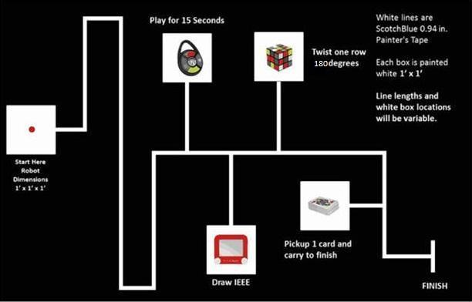The course, as shown in **Fig. 7** below, shows the rough outline of the track the system will follow, as well as what a challenge station would look like.

**Fig. 7** Competition course for SoutheastCon[1].

## **Simon Carabiner**

The Simon Carabiner, as seen in **Fig. 8** is the specific Simon game that the system will play.

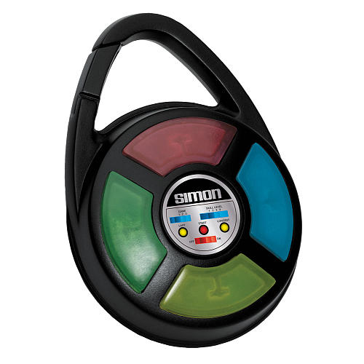

**Fig. 8:** The exact Simon Carabiner to be used during competition [5].

## **Rubik’s Cube**

The Rubik’s Cube, as seen in **Fig. 9** is the specific Rubik’s Cube that the system will play.

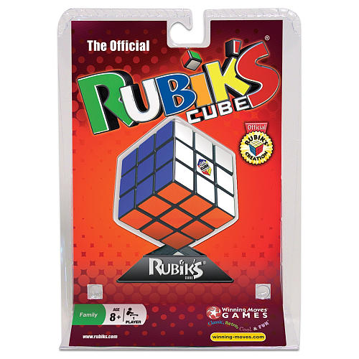

**Fig. 9:** The exact Rubik's Cube to be used during competition [6].

## **Pocket Etch-A-Sketch**

The pocket Etch-A-Sketch as shown in **Fig. 10** is the specific pocket Etch-A-Sketch the system will play.

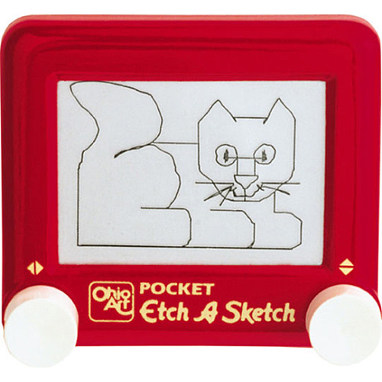

**Fig. 10:** The exact pocket Etch-A-Sketch to be used during competition [7].

## **Playing Cards**

The Bicycle Brand Standard playing cards shown in **Fig. 11** are the exact cards to be used during competition.

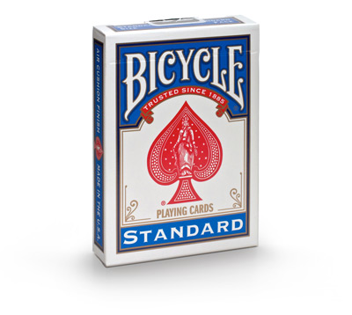

**Fig. 11:** The exact playing cards to be used during competition [9].

## **Scotch Blue Painter’s Tape**

The Scotch Blue Painter’s Tape as show in **Fig. 11** is the exact painter’s tape that will be used to designate the line the system must follow.

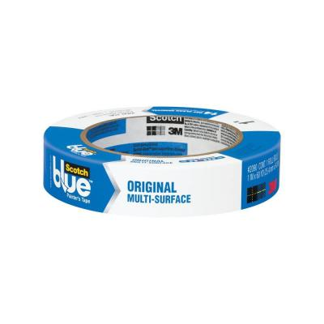

**Fig. 12:** The exact painter’s tape to be used on the course [8].

# **References**

[1] IEEE Nova Southeastern University. (2014, September 7). IEEE SoutheastCon 2015 Student Program - Hardware Competition. Retrieved September 7, 2014, from IEEE SoutheastCon 2015: http://www.ewh.ieee.org/reg/3/southeastcon2015/StudentProgram.html

[2] Rembold, U., & Fatikow, S. (1997). Autonomous Microbots. Journal of Intelligent and Robotic Systems, 19(4), 1.

[3] SoutheastCon. (n.d.). Retrieved September 13, 2014, from http://www.ewh.ieee.org/reg/3/southeastcon/

[4] "IEEE About IEEE." IEEE. N.p., n.d. Web. 12 Sept. 2014, from http://www.ieee.org/about/index.html.

[5] Simon Carabiner. (n.d.). Retrieved September 15, 2014, from http://www.toysrus.com/buy/card-puzzle-games/simon-carabiner-1850-3839349

[6] Rubik's 3x3 Cube. (n.d.). Retrieved September 16, 2014, from http://www.toysrus.com/buy/brain-teasers/rubik-s-3x3-cube-wm5027-29224016

[7] Pocket Etch A Sketch - Red. (n.d.). Retrieved September 16, 2014, from http://www.toysrus.com/buy/etch-a-sketch-doodle-pro/pocket-etch-a-sketch-red-5163-2395954

[8] 3M 0.94 in. x 60 yds. Painter's Tape-2090-24J at The Home Depot. (n.d.). Retrieved September 16, 2014, from http://www.homedepot.com/p/ScotchBlue-0-94-in-x-60-yds-Painter-s-Tape-2090-1J/100085823

[9] "Bicycle Cards." Bicycle® Standard Index Cards. Accessed November 21, 2014. http://www.bicyclecards.com/products/playing-card/bicycle-standard-index.